**Math 120  
4.1 Exponential Functions**

# **Objectives:**

1. Evaluate exponential functions.
2. Graph exponential functions.
3. Evaluate functions with base *e*.
4. Use compound interest formulas.

We have learned various types of functions:

* Linear
* Quadratic
* Rational
* Polynomials

In this Unit we will learn two new types of functions. They are inverses of each other (think back to section 1.8)

* Exponential Functions
* Logarithmic Functions

# **Topic #1: Definition of an Exponential Function and Their Graphs**

Exponential functions occur when the independent variable is a power to some positive base:



Where is the ________________and is a positive constant (other than the number ) and is any real number.



The -intercept for any exponential function in this form is the point ________________________



Consider the graph of the base “doubling” exponential function:

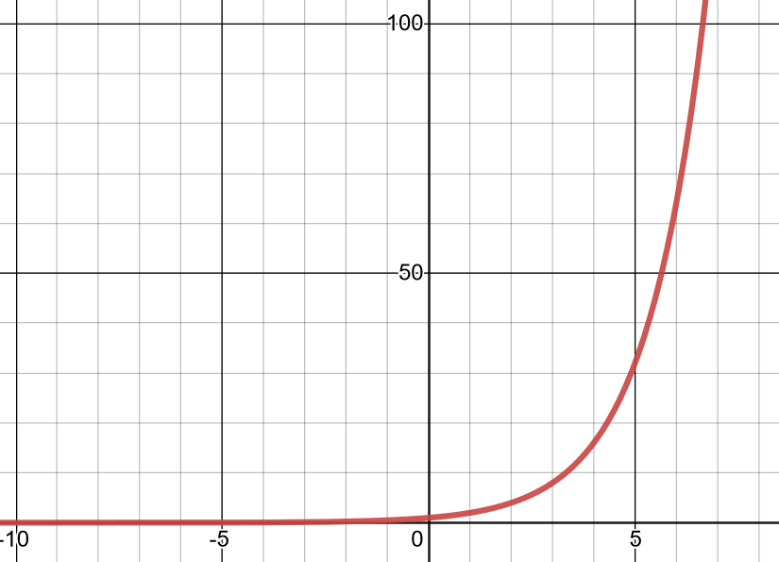

The base is and the curve is smooth, so the domain is all real numbers_________________.



Moving to the right, the curve grows rapidly and without bound. Moving to the left, the curve flattens to the horizontal asymptote of ____________________. This gives the range as __________________



Any base where has a similar curve; as the base gets larger the exponential function grows faster.

Consider the graph of the base “halving” exponential function:

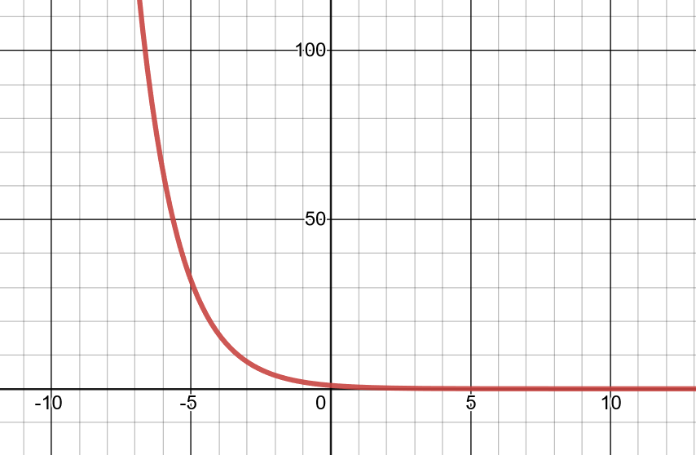

The base is and the curve is smooth, so the domain is all real numbers __________________



Moving to the right, the curve flattens to the horizontal asymptote ___________________. Moving to the left, the curve grows rapidly and without bound. This gives the range as ________________



Any base where has a similar curve; as the base gets closer to zero the exponential function decreases faster.



*Example #1* – Sketch a Graph of the Exponential Function

a)

Since the function grows without bound and moves to the horizontal asymptote to the left.

REMINDER:

Pick a few values and plot the points:

| x | -3 | -2 | -1 | 0 | 1 | 2 | 3 |
| --- | --- | --- | --- | --- | --- | --- | --- |
| f(x) |  |  |  | 1 | 4 |  |  |



Notice the values are increasing by a factor of , that is because .

Notice negative inputs __________________give negative outputs. It is due to the property of exponents:

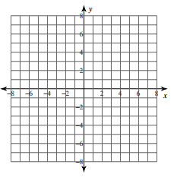 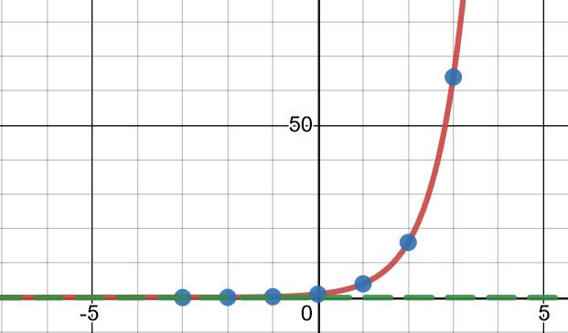

Since the function decreases and moves to the horizontal asymptote to the right.

REMINDER:

Pick a few values and plot the points:

| x | -3 | -2 | -1 | 0 | 1 | 2 | 3 |
| --- | --- | --- | --- | --- | --- | --- | --- |
| f(x) |  |  |  |  |  |  |  |



Notice the values are decreasing by a factor of 1/3, that is because .

 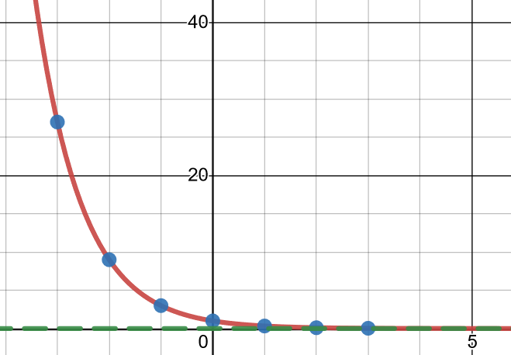

Notice negative inputs _________________ give negative outputs.



The exponent is negative, so we need to be careful since it is not in the base form definition.

Alternatively, we could use the property of exponents to rewrite in base form:



In this form, we see the exponential function has a base which is confirmed by the graph.

Plot some points to get a sense of what happens left to right:

| x | -3 | -2 | -1 | 0 | 1 | 2 | 3 |
| --- | --- | --- | --- | --- | --- | --- | --- |
| f(x) |  |  |  |  |  |  |  |



Plotting the points shows the function decreases and moves to the horizontal asymptote to the right.

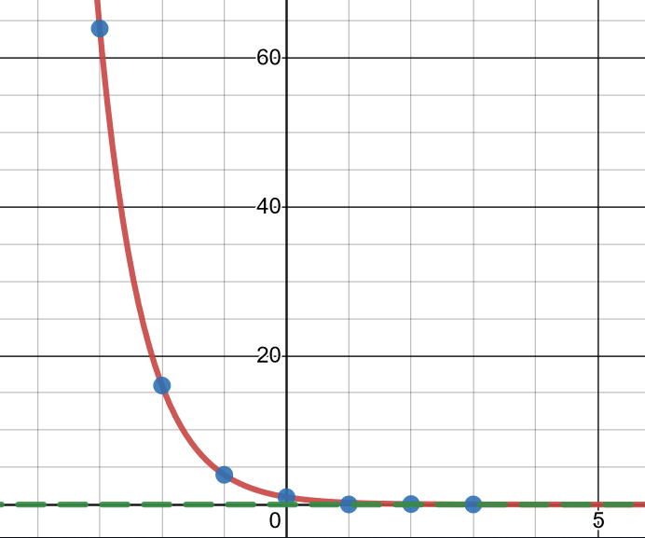

The exponent is negative, so we need to be careful since it is not in the base form definition.

Again, we could rewrite:



Plot some points to get a sense of what happens left to right:

| x | -3 | -2 | -1 | 0 | 1 | 2 | 3 |
| --- | --- | --- | --- | --- | --- | --- | --- |
| f(x) |  |  |  |  |  |  |  |



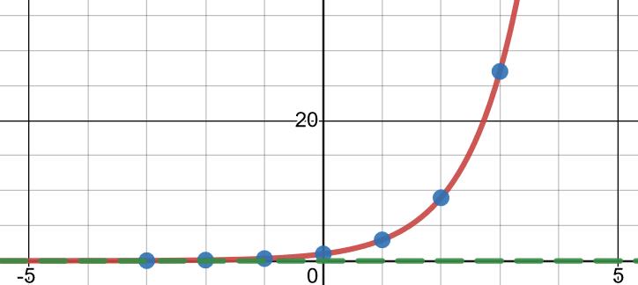

# **Topic #2: Compound Interest**

Money in a savings account earns interest over time. When interest is compounded, the amount in the account earns interest, then the interest is added to the balance, and the new value becomes the amount in the account. The process of accumulating interest repeats and eventually the initial value invested grows significantly.

Compound interest is interest paid on both the original principal and on all interest that has been added to the original principal.

Suppose you invest $100 in two accounts that each pay an interest rate of 10% per year, but one pays ***simple interest,*** and the others pays ***compound interest***. Make a table to show the growth of each over a 5-year period.

Simple Interest Account Compound Interest Account

| End of year | Interest Paid | Old Balance + Interest = New Balance | Interest Paid | Old Balance + Interest = New Balance |
| --- | --- | --- | --- | --- |
| 1 | 10% x $100 = $10 | $100 + $10 = | 10%x$100 = | $100 + $10 = |
| 2 | 10% x $100 = $10 | $110 + $10 = | 10%x$110 = |  |
| 3 | 10% x $100 = $10 | $120 + $10 = |  |  |
| 4 | 10% x $100 = $10 | $130 + $10 = |  |  |
| 5 | 10% x $100 = $10 | $140 + $10 = |  |  |

Here is the formula for compound interest:



Where

is the



is the



is the



is the

is the



The most common ways interest is compounded per year are:

| Name | Annual | Semiannual | Quarterly | Monthly |
| --- | --- | --- | --- | --- |
| Times per year |  |  |  |  |

Suppose a person has an initial investment of in an account that is compounded quarterly at a interest rate. This tells us . Using these values in the compound interest formula, we get the function:



The only variables are time in years, , and the new value, , over time.



Here is a graph of the function:

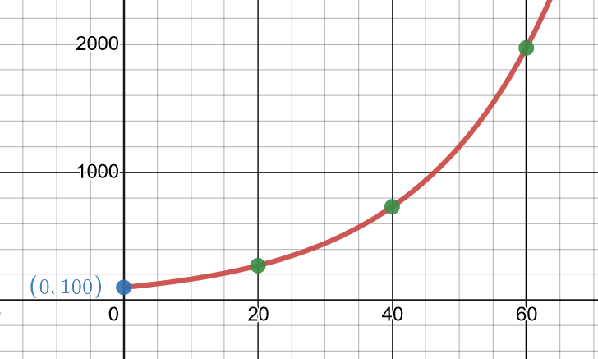

Notice the new amount in the account starts growing slowly, but eventually increases dramatically!



That is the result of an exponential function where the base is .



To the nearest cent:

when ,



when ,

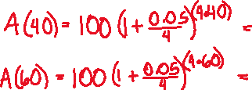

when ,



*Example #1* – Calculate the Accumulated Value

a) Find the accumulated value of an investment of for 5 years at an interest rate of 5.5% compounded semiannually.

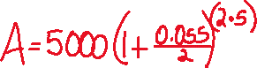

b) Find the accumulated value of an investment of for 5 years at an interest rate of 5.5% compounded monthly.

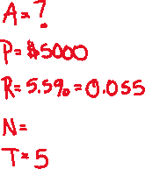

Note: The only difference in the two examples above is the number of times compounded per year. The monthly compound earned about more than the quarterly.



# **Topic #3: The Natural Base and Continuous Growth**

*Introduction to the number :*

Suppose a person deposits $1 into an account for 1 year and the account has an interest rate of 100%. This gives . Using these fixed values in the compound interest formula gives the function:



The only variables are how **________________________** the interest is compounded, , and the accumulated value, , over the number of times the interest is compounded.



What happens when increases?



Through intuition, the higher gets should produce a higher value for .



However, consider the table of values when the interest is compounded: once, quarterly, monthly, daily, by the hour, by the minute, and by the second:

|  |  |
| --- | --- |
| **N** |  |
| 1 | 2 |
| 4 |  |
| 12 |  |
| 365 |  |
| 8760 |  |
| 525600 |  |
| 31536000 |  |

Notice that when gets large, that looks to flatten out to the value _________________________



We can break one year up into as many tiny little pieces as we want (which is what does).

This introduces a very useful number, . The number is irrational and is approximately:

…

The function is called the

_______________________________since base models continuous change (meaning, there are no breaks in how something changes over time, which is a **natural** occurrence).



Here is the graph:

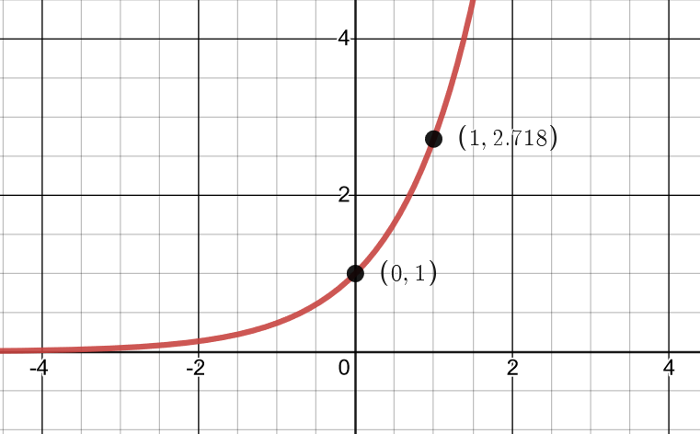

Here is a table of select values for the natural exponential function (approximated)

| x | -3 | -2 | -1 | 0 | 1 | 2 | 3 |
| --- | --- | --- | --- | --- | --- | --- | --- |
| f(x) | 0.04979 | 0.13534 | 0.36788 | 1 | 2.7183 | 7.3891 | 20.086 |

*Continuous Interest:*

When the number of times that interest is compounded per year is continuous, the formula for compound interest no longer applies (since becomes infinite). Here is the formula for continuous interest:



Where

is the



is the



is the



is the



Although it is highly unlikely that a bank would compound interest continuously, the formula for continuous interest is useful since it introduces the concept of continuous change. Time never stops in nature and base is the perfect number to model how things change when the “clock never stops”.



*Example #1* – Calculate the Future Value

a) Suppose a person wants to invest in an account that is compounded continuously at a interest rate. How much will be in the account after 20 years? 40 years? 60 years?

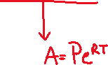

We can also use the formula:



when ,



when ,



when ,



We can plug this function into the calculator to help evaluate at the indicated times.

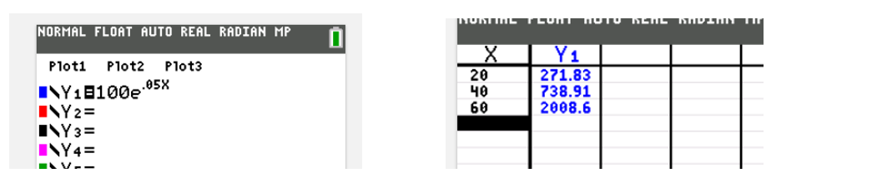

b) A person has to invest for 4 years. One bank offers an interest rate of 7% compounded monthly, another bank offers an interest rate of 6.85% compounded continuously. Which offer will earn a yield a higher return on the investment?



Use the appropriate model and inputs to compare:

Option #1:

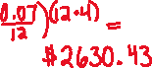

Option #2:



# **Topic #3: Other Applications of Exponential Functions**

Exponential functions are useful to model changes in quantities over time.

*Example #1* – Exponential Growth of a Population

The exponential function models the population of India, in millions, years after 1974.

Let x be:



Let f(x) be:



a) Find and interpret the meaning.



b) According to the model, what was the estimated population in 2001? Round to the nearest whole number (which gives the population to the nearest million).



c) According to the model, what is the projected population in the years 2028 and 2055? Round to the nearest whole number and include units.



d) What appears to be happening to India’s population every 27 years?

The years above are in 27 year increments:

The corresponding populations (in billions) are:



The model suggests **the population will**

**____________________________**



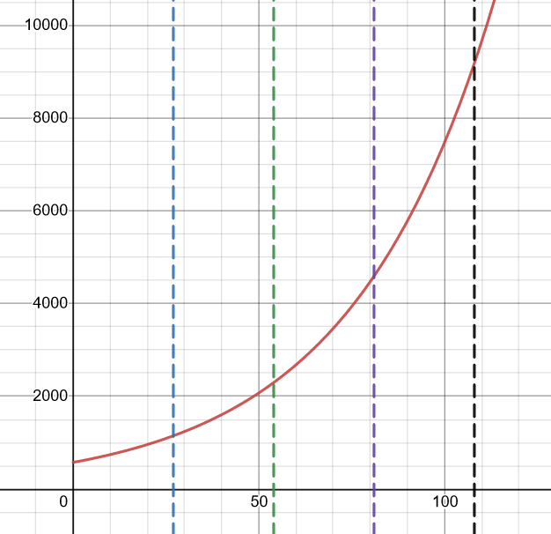

*Example #2* – Exponential Decay of Learned Information

The exponential function describes the percentage of information that the average person remembers weeks after learning the information.

Let x be:



Let f(x) be:



a) What percentage of information is initially retained when it is first learned?



b) What percentage of information is retained after 1 week? After 4 weeks?

Evaluate:



c) Graph the function. Think about your domain and range. What will your window be?



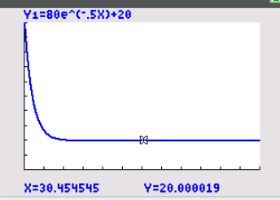



d) What happens to retention as the time after learning the information increases?



e) Use the graph to estimate how long it takes retention to drop to 50%. Round to the nearest week.



